Requirements/Design Specification

**CRM – Enlarge Font with Quote Status**

**GH 524 – CR 13929**

Revision History

|  |  |  |  |
| --- | --- | --- | --- |
| **Date** | **Revision** | **Description** | **Author** |
| 4/29/2015 | 1.0 | Initial Version with Requirements | Roger Behm |
|  |  |  |  |
|  |  |  |  |
|  |  |  |  |
|  |  |  |  |

The information furnished herein by Republic Services Inc. is proprietary and confidential to Republic Services Inc. personnel and is not to be duplicated, published, or disclosed to any third party in whole or in part without permission from Republic Services, Inc.

© Copyright 2012, Republic Services Inc. - All rights reserved.

Table of contents

1 Business Requirements/Owner – Brittany Smith 6

1.1 Purpose of the Design Specification 6

2 Assumptions 6

3 Design 6

4 InfoPro/TIBCO/BI Impacts 6

5 Report Changes 6

6 Appendix 6

# Business Requirements/Owner – Brittany Smith

## Purpose of the Design Specification

On the Finalize screen, enlarge font for "Customer Accepted: Signed" so it's easier to read/notice.

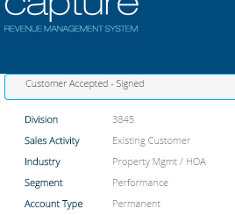

# Assumptions

NA

# Design

Up the font in the css for the contractFinalized element in the header box on the finalized screen. (capture/css/devrepublicservicesAlt.css)

# InfoPro/TIBCO/BI Impacts

No new variable should be needed and no existing variables should be repurposed for any of the above changes.

# Report Changes

NA

# Appendix